Introduction
This is a stocks and flows-style model to facilitate demand and capacity modelling of patient pathways. If a pathway can be mapped as a flow diagram with known proportions for the outcome of each event, then it can be modelled with this approach.
The outputs will show the change in waiting list size over time. This can be used to identify bottlenecks in a pathway. The outputs will also show how much activity can be expected based on the input demand and capacity.
There are four model configuration files, which set up the model to match the pathway, and two scenario configuration files which hold inputs for the planned demand and capacity for a given scenario. Multiple scenarios can be run and the results compared.

Example 1 Flow Diagram:
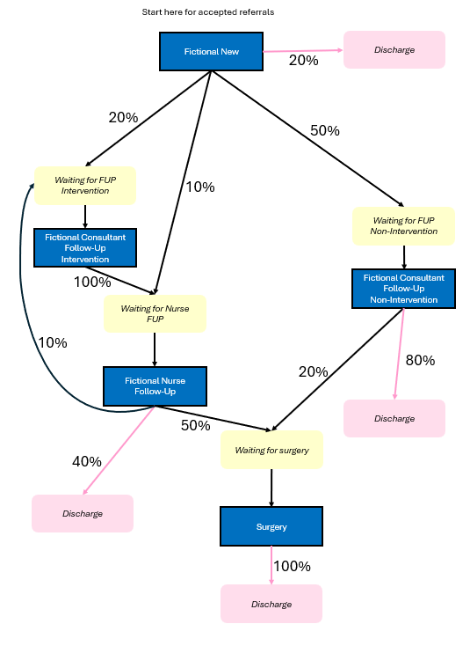

High-level Overview
Model i.e. The Pathway – What you need to be able to input
The modeller needs to know (1) what events can happen on the pathway (events are usually a type of appointment), (2) what the different possible outcomes are for a patient after those events, and (3) what statuses a patient can have (statuses are usually “waiting for X”). This is the same as the information in Example 1 Flow Diagram on the previous page.
The model configuration comprises four essential CSV files. There are also three additional optional tables to include extra features:
- Events (what can happen to a patient)
- Statuses (where in the system a patient can be at a point in time)
- Event-Outcome table (when a patient has a specific event, what are the possible outcome statuses and the likelihood of each)
- Event-Recipient table (for each event, which status it happens to)
- Optional: Event-Event Group table (for each event, does it use the same capacity as other events)
- Optional: PIFU Percentages (distribution of patient initiated follow-up returns over time)
- Optional: Booking rates (for each event, what percentage of slots are successfully booked into)
Scenario i.e. Demand and Capacity – What you need to be able to input
Each scenario needs to include who is coming into the pathway (i.e. the demand) and how much resource is available for each event (i.e. the capacity). This should include the current situation, and any future changes to be modelled such as a planned increase in capacity.
The scenario configuration comprises two CSV files:
- Current waiting list (how many patients are currently at each status)
- Future demand and capacity (rate of new referrals coming in, and how many of each appointment will be available each month/week)
It's recommended that new users look at the folder example_1 to see a practical example of what the config files should look like.

Detail
All CSVs include column headers
- Model (model_events)
This table is just one column, which is list of all distinct events to be modelled.
The event “New Referral Received” is a special event (hardcoded) – if you don’t list it in the events table, the model will automatically add it to make sure it’s there. However, it’s best practice to list it in the events table, to remind you that you need to think about it when writing the other model_event tables below.
- Model (model_statuses)
Three columns. Column A is a list of distinct statuses. Column B is an indicator to say which statuses are “exit” statuses, i.e. they are ways that the patient leaves the system (if they reach this status then nothing further will happen to them). Column C is a percentage ROTT rate – the rate that patients drop-off or are removed from the waiting list while waiting for this appointment (without ever having the appointment).
- Model (model_event_recipient)
This table has two columns. Column A is a list of all events, and column B specifies which status each event will apply to. This should be a 1-1 relationship.
The event “New Referral Received” is a special event and should have recipient “N/A”.
Statuses which were marked as exit statuses in the model_statuses table will not need to appear in column B. For a functioning pathway with no “dead ends”, all other statuses should appear in this table in column B. Exit events must be defined.
- Model (model_event_outcome)
This is a many-to-many table with events in column A and statuses in column B.
Events can result in different outcomes (for example, the event “New Appointment” could result in either “Waiting for FUP” or “Discharged”). Each event will have the same number of rows as possible outcomes. Column C is the likelihood of each outcome, as a proportion (for example, if a quarter of patients are “Discharged” after “New Appointment”, then the likelihood of this outcome is 0.25). For each event, the likelihoods in column C should add up to 1. For a functioning pathway, all statuses should appear at least once in column B.
Note that even though “New Referral Received” doesn’t have to be specified in the event table, it needs to be included in this table to say what happens to new referrals.

- Scenario (scenario_demand_initial)
This file is for the starting situation. Usually we’re starting from now, so this is the current waiters (or waiters at the beginning of this month/week). There should be one row for every status in the statuses table.
- Scenario (scenario_capacity_and_demand_referrals)
Column A is a list of dates. These dates should be equally spaced periods, e.g. months/weeks/fortnights, and must be in order. Note that there must be at least 12 rows (i.e. 12 dates) in this file.
The model allows a patient to have a maximum of one event in each date period – if there’s enough capacity then the patient will have the appointment, or if not then the patient will wait until the next period. Therefore when choosing spacing, it’s recommended to factor in how far ahead appointments are booked. If the service is booking patients into appointment slots 3 weeks in advance of the appointment date, then monthly date spacing is recommended (i.e. spacing is similar to the booking time but slightly longer). In this example, if weekly spacing is used the model would incorrectly assume that patients can have their second appointment the week immediately after their first appointment.
Column B is the number of new referrals expected each month/week/fortnight.
All further columns are capacities, and must be named “Capacity X” where X is the event name exactly as spelt in the events table.
Make sure that row 2 is the start date for the model, i.e. the period that corresponds to what you put in scenario_demand_initial. This is usually the current week/month.

Further Advice
When defining the model, remember that every event happens to only one type of recipient. If there are waiters who could have one of two types of appointment, imagine that it’s predetermined which type of appointment they will have next.
It is important that the date spacing in scenario_capacity_and_demand_referrals roughly represents how long a patient is going to wait between consecutive appointments (if there’s no massive backlog of waiters).
ROTT is only accounted for via the column of the same name in model_statuses. No other ROTT rate is incorporated into the modelling. If the ROTT column is left blank, we assume that patients always stay on the waiting list until they’re seen.

Optional Additions
Optional addition – event groups
If there are multiple appointments that use the same capacity (e.g. ENT Urgent New, ENT Routine New, ENT Routine New Phone), these can be grouped so that they model will dynamically assign capacity to each event in the group, according to set priorities.
- Optional additional table: Model (model_event_group) – OPTIONAL
Column A should be a list of all events (same list as the model_events table). Column B should be the group for each event, but will be left blank where the event is ungrouped. Column C should be the priority for each event within its group, which is consecutive integers starting at 1 for the highest priority (e.g. ENT Urgent New has priority 1, and both ENT Routine New and ENT Routine New Phone have priority 2). Column C should be blank where column B is blank.
If the optional model_event_group is being used, for events that have a group there one needs to be just one column in scenario_capacity_and_demand_referrals for each event group rather than separate columns for individual events.

Optional addition - PIFU
If the pathway being modelled includes PIFUs (patient initiated follow ups), there should be statuses such as “Patients on unactivated XYZ PIFU” which appear as outcomes for some events. There should be corresponding events “PIFU activated – XYZ” which have the PIFU statuses as their recipients in the event_recipient table. The wording used for these statuses and events doesn’t need to be exact, but the events must be given the event group “PIFU activated” in model_event_group and should all be given a priority of 1.
“PIFU activated” is a special event group. This event group doesn’t need a capacity column in scenario_capacity_and_demand_referrals, because there’s no limit to the number of PIFUs that can be activated.
For PIFUs, in the scenario_demand_initial table this should be the total number of patients who were put onto PIFU in the last 12 months, regardless of whether they have since activated the PIFU.
- Optional additional table: Model (model_pifu_percentages)
If the model includes PIFU, this file can be used to customise the speed at which PIFU orders are activated. It requires two columns. Column A is the month number, and column B is the proportion of PIFUs that return that month (out of all PIFUs that return). Percentages should add up to 100%. It is strongly recommended that the minimum percentage for any non-zero month of PIFU returns is 3%, otherwise numbers in the modelling become too small to be meaningful. If this file is not included, a default, synthetic distribution of returns over 12 months will be used instead.
If using weekly or fortnightly date periods in scenario_capacity_and_demand_referrals, the default PIFU distribution should not be used. A custom PIFU distribution should be set in terms of weeks.
If using the model_pifu_percentages file (i.e. using custom PIFU return timelines) then the scenario_demand_initial table should have the number of patients who were put onto PIFU in the last X months, where X is the number of rows in the model_pifu_percentages file.
If using a custom pifu return rate that is longer than 12 months, the scenario_capacity_and_demand_referrals table must have at least that number of rows/dates.

Optional addition – Booking Rates
- Optional additional table: Model (model_booking_rate)
If there are types of appointments on the pathway where not all appointment slots can be filled (even when there is enough demand to fill all slots, this file can be used to add a custom booking rate (between 0% and 100%) to reflect the proportion of slots that can be filled. For example, if a clinician offers 20 slots per month but two are reserved for writing up letters, we would say their booking rate is 90%.
It requires two columns. Column A is a list of some event groups (or events if the model_event_group file is not in use). Column B is the booking rate for each event. For events/event groups not listed in this table, the booking rate is assumed to be 100%. Note that this booking rate is as well as a DNA rate (the DNA rate in the model is fixed at 3%).
If this file is not included, all booking rates are assumed to be 100%.

